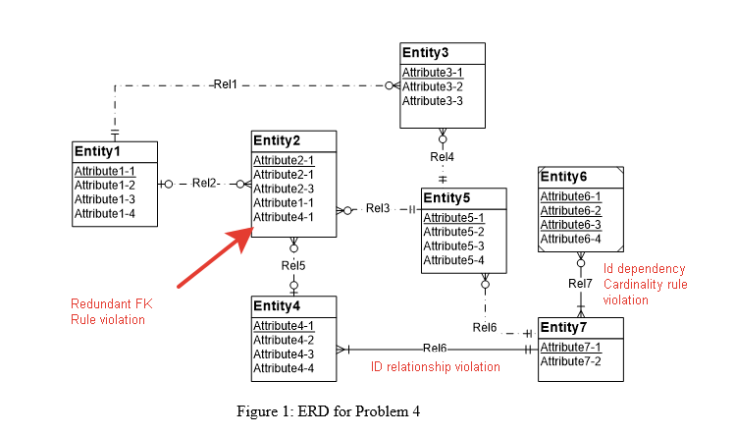

There are 3 rules violations. You can see them at fig.1.

To fix it:

1. Delete Attribute 4-1 from Entity2
2. Make Entity4 a weak entity
3. Make rel7’s cardinality as one and only to many